# DDL in-class practice

Use this model as reference for practice problems below

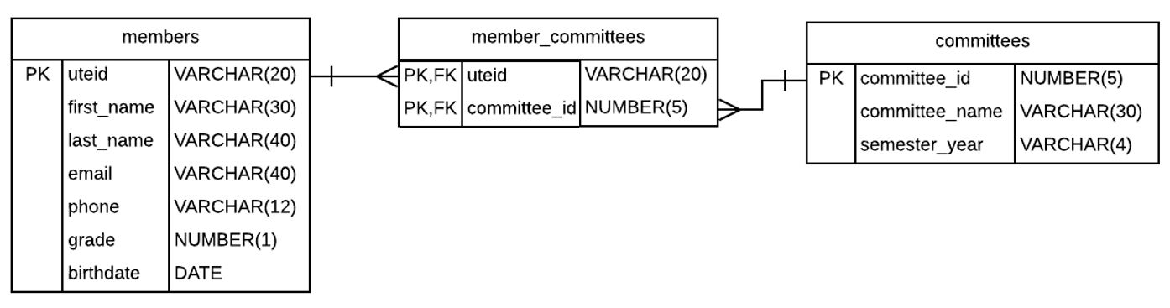

**Task: Complete the following**

1. Create the ***members*** table with the key and data types noted in ERD and test with seeding data
2. Create the ***committees*** table with the key and data types noted in ERD and test
3. Create the ***members_committees*** table with composite PKs and two FKs. This requires table-level constraints.
4. Test constraints of tables. (i.e. Can you enter two members with same uteid or two committees with same id? Can you assign a member that doesn’t exist on member table to a committee? Vice versa for a committee?)
5. Add Check constraint to ***members***. The ***grade*** column should be greater than 0. *Hint: You can do this either by dropping the table and recreating it with an updated CREATE statement or use an ALTER statement to add this check constraint.* Once you add it, test the constraint works.
6. Update the check constraint on ***grade*** to only allow grade column to contain a value of 1,2,3, or 4. *Hint: Either alter the constraint on grade OR drop the constraint and re-add it with new logic.*
7. Change the ***phone*** column’s name to be ***phone_num***. Note: this isn’t in book so you’ll need to google it.
8. Add a UNIQUE constraint to members.email. Again, you can drop and create table or add an ALTER statement.
9. Change the length of a column. e.g. UTEID should be a max length of 10.
10. Change a column’s data type. e.g. Change phone from VARCHAR to CHAR
11. Add a new column with a default constraint. e.g. Add a “status” column to committees with a default value of “active”. Test constraint.
12. Edit the “status” column by modifying the data max length to be 1 and the default constraint to be “A”. Also add a check to allow a value of “A” or “I” only for active or inactive.
13. Change the name of a table. Refresh left panel in SQL Developer to see change took affect
14. Truncate a table that has data in it.
15. Drop a table. NOTE: You’ll have to drop a specific one first
16. Drop a constraint
17. Drop a column
18. Use the SQL Developer GUI (Graphical User Interface) to do 13-15 again